GIT CODING ASSIGNMENT 1
NAME: VARSHA MATTA
ROLL NO.: 95802
BATCH: IIT-08-M-C-MERN
DATE OF SUBMISSION: 16/01/2026

Question 1
Verify that Git is correctly installed on your system and record the version displayed.
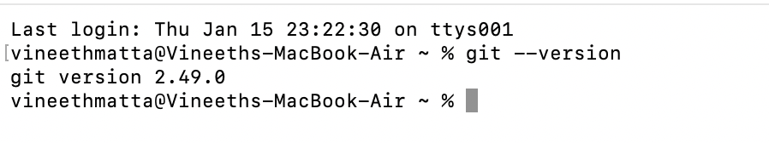
Ans- git version 2.49.0

Question 2
Configure Git with your global username and email ID, and verify that the configuration
has been applied successfully.
Ans- Configured username:VarshaMatta
Configured email ID:varshamatta3@gmail.com
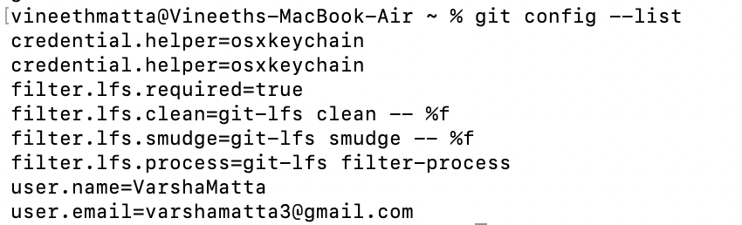

Question 3
Create a new local Git repository named git-assignment and initialize version control in it.
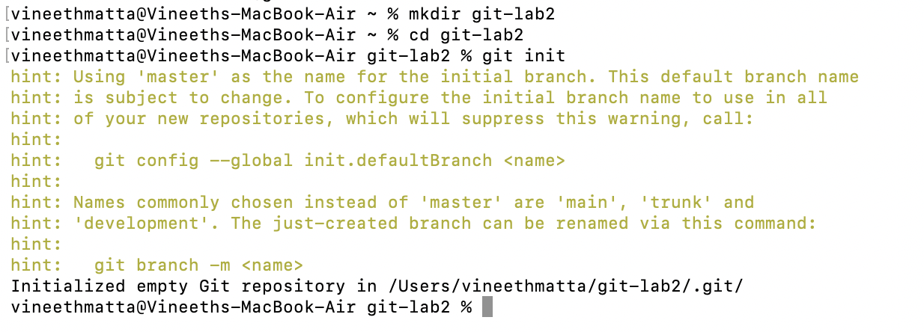
Ans- mkdir git-lab2
cd git-lab2
git init
Question 4
Create a README.md file inside the repository, add relevant project information, and commit
the file to the repository.
Ans- File created: README.md
Commit message used: git commit -m ”Added README.md file”
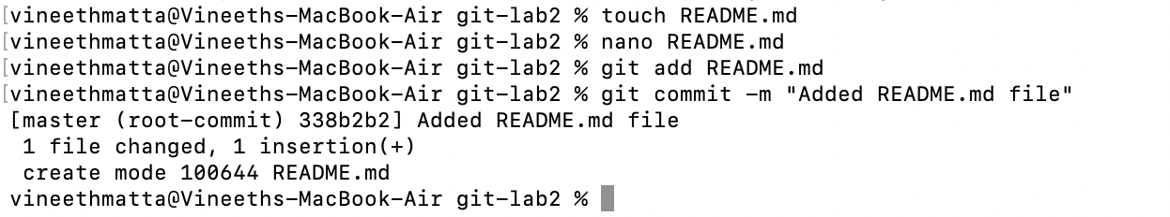
Question 5
Modify the existing README.md file and create a new file named index.html. Track the
changes and commit them with an appropriate commit message.
Ans-Modified file: README.md
New file created: index.html
Commit message used:git commit -m”Updated README.md file and added index.html”
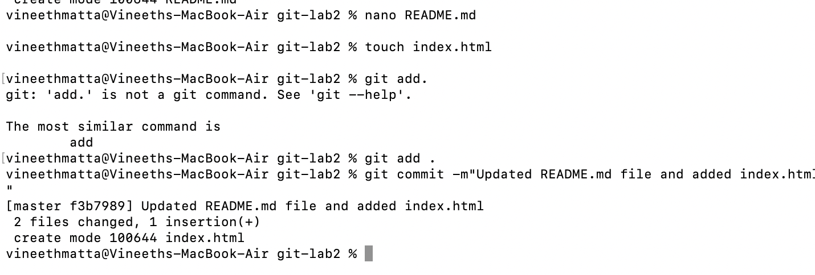
Question 6
Display the commit history of the repository and identify the commit hash, author, and
commit message.
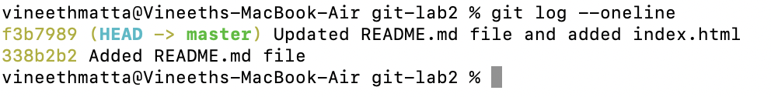
Ans-
Question 7
Create a new branch named feature-branch, switch to it, add a new file named
feature.txt, and commit the changes.
Ans- Branch created: feature-branch
File added: new.txt
Commit message used: git commit -m “Added new.txt file”

Question 8
Switch back to the main branch and merge the feature-branch into it. Ensure the merge is
completed successfully.
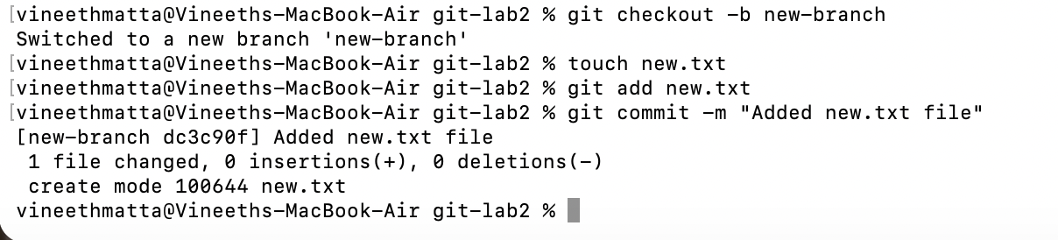
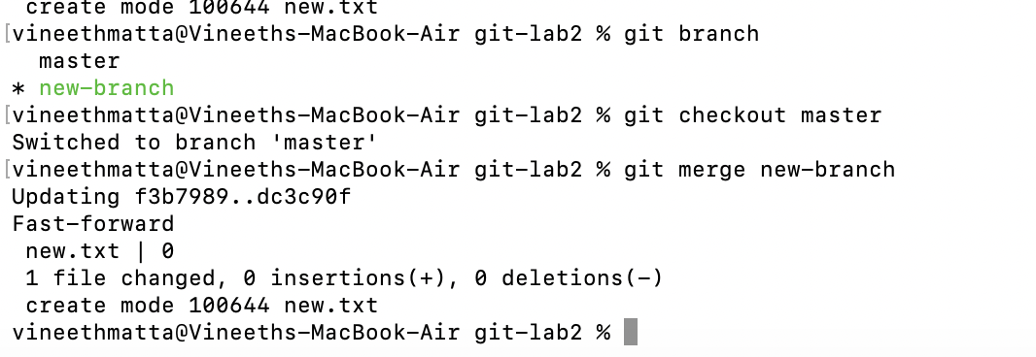
Ans- successful merge status- 1 file changed, 0 insertions(+), 0 deletions (-)
Question 9
Create a new remote repository on GitHub named git-assignment and push the complete
local repository to GitHub.
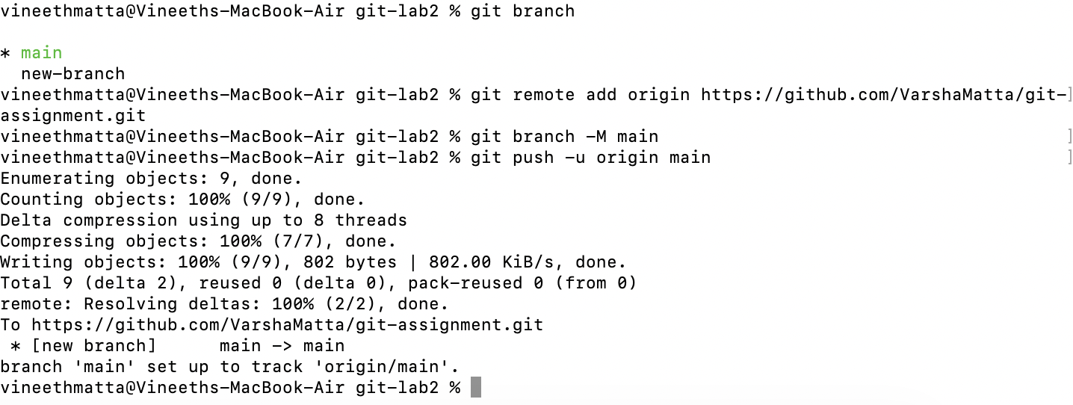
Ans- GitHub repository URL: https://github.com/VarshaMatta/git-assignment

